**MOHD AZRAF BIN MOHD RAZIF**

No. 52, Perumahan Bkt. Kenau, Pulau Manis

26640 Pekan Pahang

012-9870468

azrafrazif@gmail.com

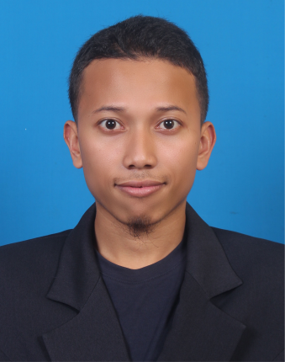

|  |  |  |
| --- | --- | --- |
| **INTRODUCTION** |  | Recent graduate with a **Masters (Degree) of Electrical Engineering in UTM**. . Interested for a full time position. Fast learner, self motivated and positive person. |
| **activities** |  | Kursus **Kad Hijau CIDB (GREEN CARD)**  Participation as volleyball athlete in “**UTM GAMES 2012**”  Participation as Sepak Takraw athlete in “**Kejohanan Sukan Antara Kolej Mahasiswa 2010(SUKAM XVIII ‘10) UTM”**  Participation in **Gunung Lambak Pra-Experd 2010**  Bronze medal as volleyball athlete in “**Kejohanan Sukan Antara Kolej Mahasiswa 2009 (SUKAM XVIII ‘09) UTM**”  Committees for **Festival Convocation UTM (FESKO 11)**  Committee in “**Malam Puncak Perdana VIII 2010**”  Vice treasurer in program “**Perak Academic and Community Services 2010 (PACS’ 2010)**”  Vice treasurer in program “**Khidmat Bakti Siswa Semporna Academic and Community Services 2010 (PERSACS’ 2010)**”  Participation in “**Generasi al-Quran 2009**”  Participation in “**Kursus Bina Negara (Asas) 2008**” |
| **Work History** |  | INTERN, IC MICROSYSTEMS 18 June 2012-7 September 2012   * IC fabrication process &device Characterization * Digital Circuit Simulation & layout * Custom Digital IC design |
| Education |  | UTM SKUDAI, Masters of engineering (electrical), 2016UTM SKUDAI, bachelor of engineering (electric electronic), 2013CGPA: 3.33COLLEGE MATRICULATION JOHOR TANGKAK, physical science student, 2008 **CGPA: 4.00** smksp pekan, student, 2000-2007 Sijil Pelajaran Malaysia (SPM) – 7A 3B  Penilaian Menengah Rendah (PMR) – 6A 2B |
| Communication |  | **Malays** : Excellence (1A for SPM)  **English** : Good (1A for SPM)  **Malaysian University English Test (MUET)** band 3 |
| Subjects (DEGREE) |  | C programming; A, Circuit Theory: A-, Digital Electronic: A- , Microprocessor: B+, Microcontroller: A-, CAD and ASIC Design: A |
| skills & abilities |  | **MATLAB**(LEVEL: BASIC), **VISUAL BASIC**(LEVEL: BASIC), **C PROGRAMING**(LEVEL: BASIC),**SILVACO ELECTRONIC DESIGN AUTOMATION**(LEVEL: BASIC), **MICROSOFT OFFICE WORD**(LEVEL: INTERMEDIATE)**, MICROSOFT OFFICE EXCEL**(LEVEL: BASIC) |
| Publications |  | **Low complexity maritime surveillance video using background subtraction on H. 264.**  **Adaptive search window for low complexity surveillance video coding** |
| Research |  | **MODIFIED INTER PREDICTION H.264 VIDEO ENCODING FOR MARITIME SURVEILLANCE** |
| References |  | DR. MUSA BIN MOKJI **Lecturer of Universiti Teknologi Malaysia (UTM)**  musamm@utm.my  Department of Microelectric and Computer Engineering  Faculty of Electrical Engineering,  Universiti Teknologi Malaysia,  81310 Skudai, Johor Darul Ta’zim |